Alex Knight b190642042 - CSC8502 Coursework:

Action Keys:

1: Single Camera  
2: Dual Cameras  
3: No post-processing  
4: Gaussian Blur  
5: Sobel filtering

9: Start animated camera cycle  
0: Stop animated camera

Note: the animated camera is activated by key purely to prevent it running part of its course before the window has become visible to the user.

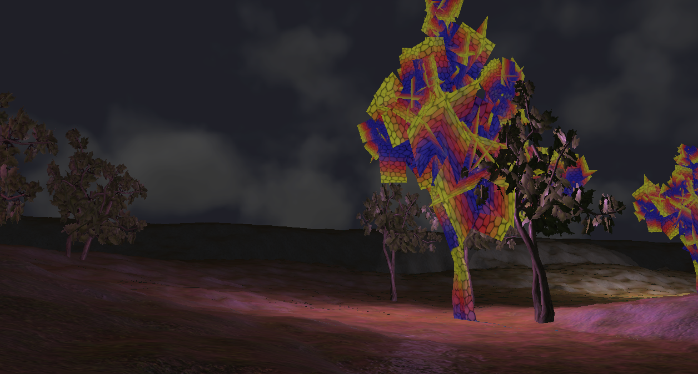

Pictured: Scene Graph Node-based objects on a multi-textured heightmap. The cubemap-based skybox is visible in the background.

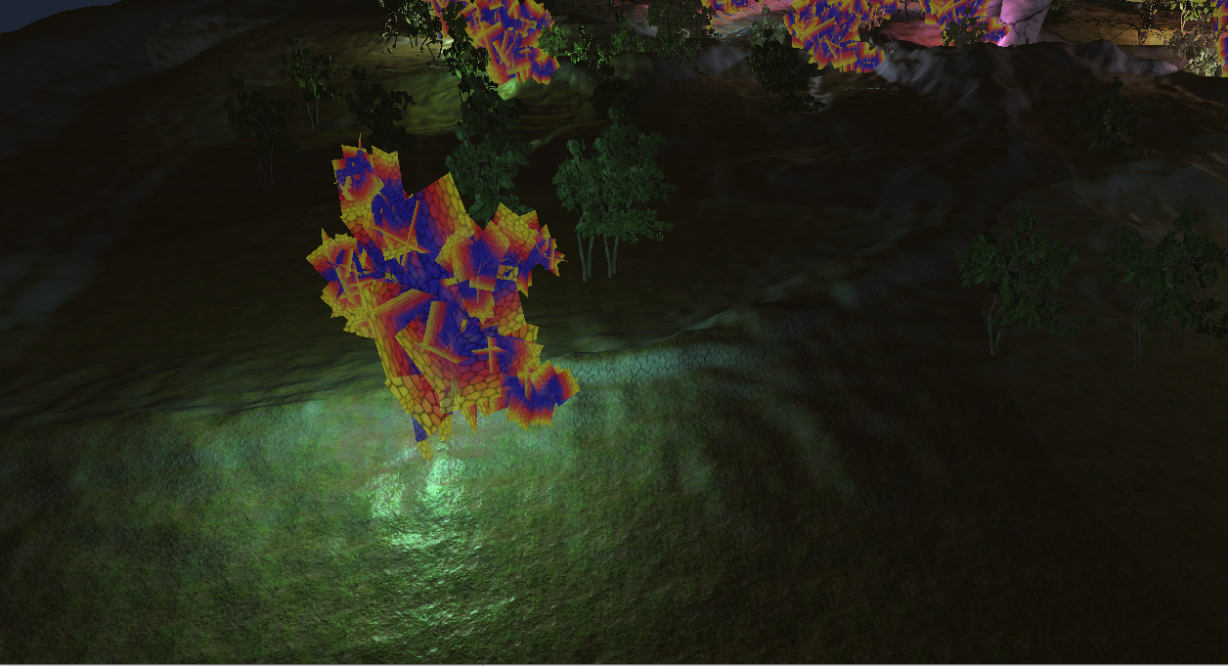

Pictured: Deferred rendering lighting, using inverse square law attenuation.

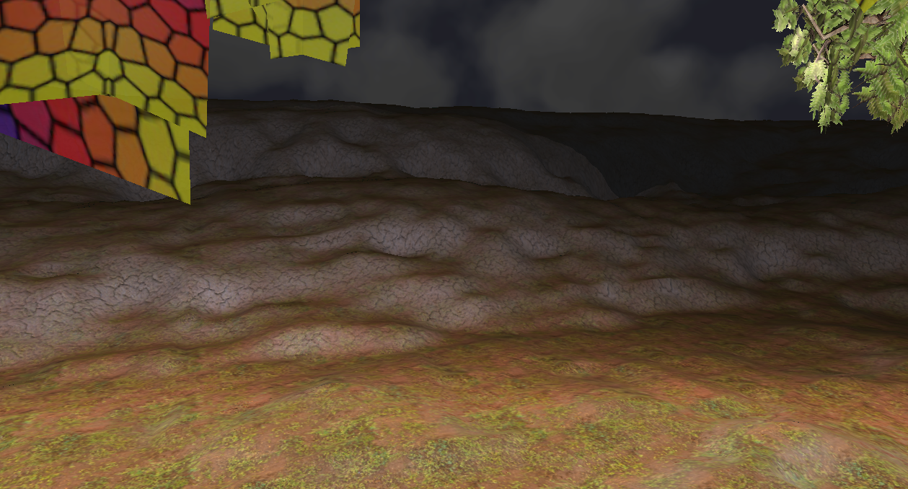

Pictured: The heightmap-based terrain, utilising multiple textures and bumpmaps, which are differentiated between based upon the vertical component of the normal of the surface, to provide a rocky texture and bumpmap on steeper slopes.

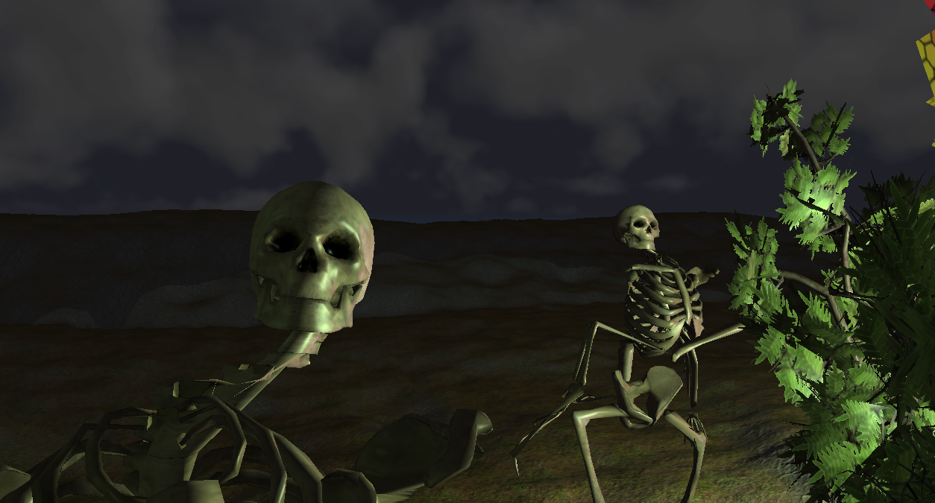

Pictured: Two animated skeletons. These are derived from a scene node child made for animated meshes, allowing any number of these to be readily created. These animated meshes perform a looping animation, and support the deferred rendering lighting.

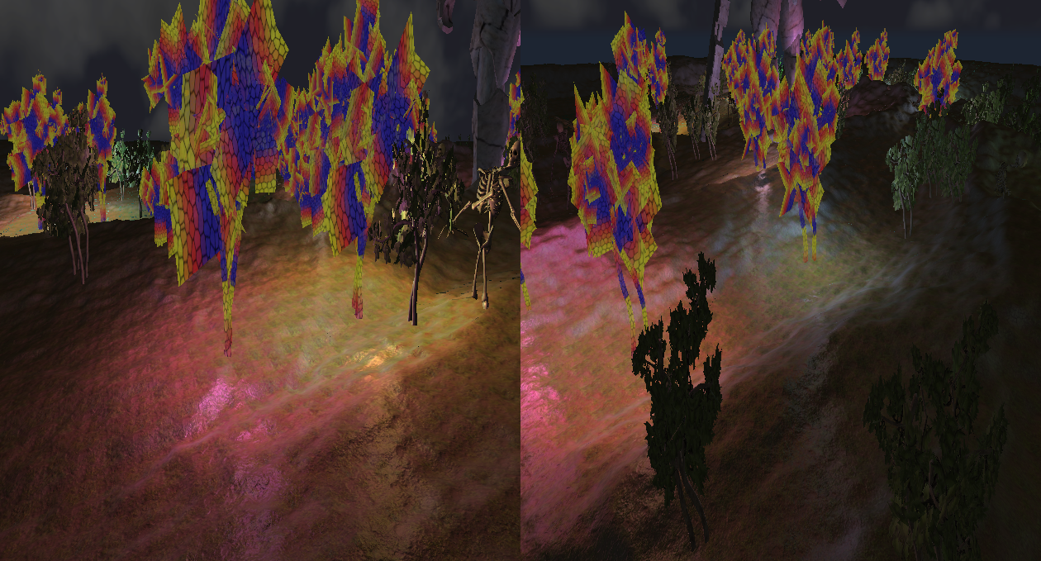

Pictured: The use of dual cameras rendering to the screen simultaneously.

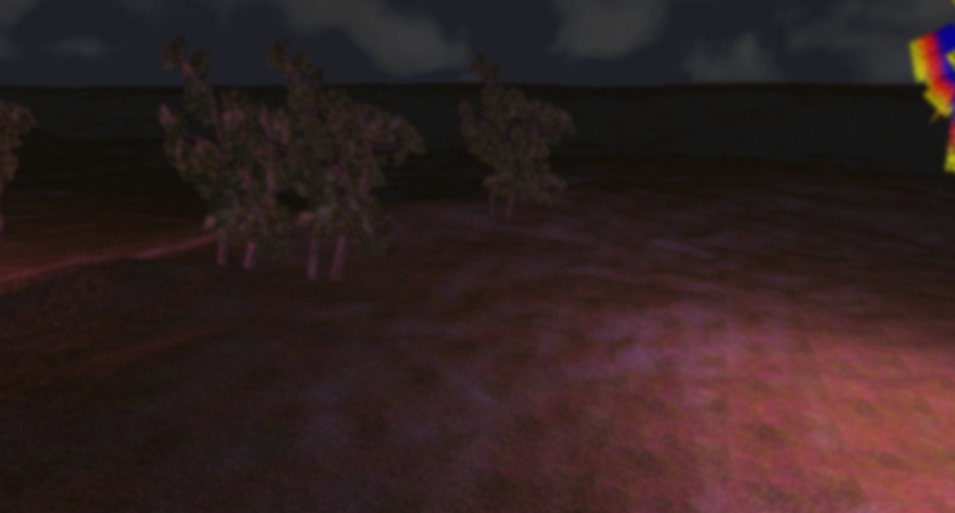

Pictured: The use of gaussian blue post-processing to blur the scene.

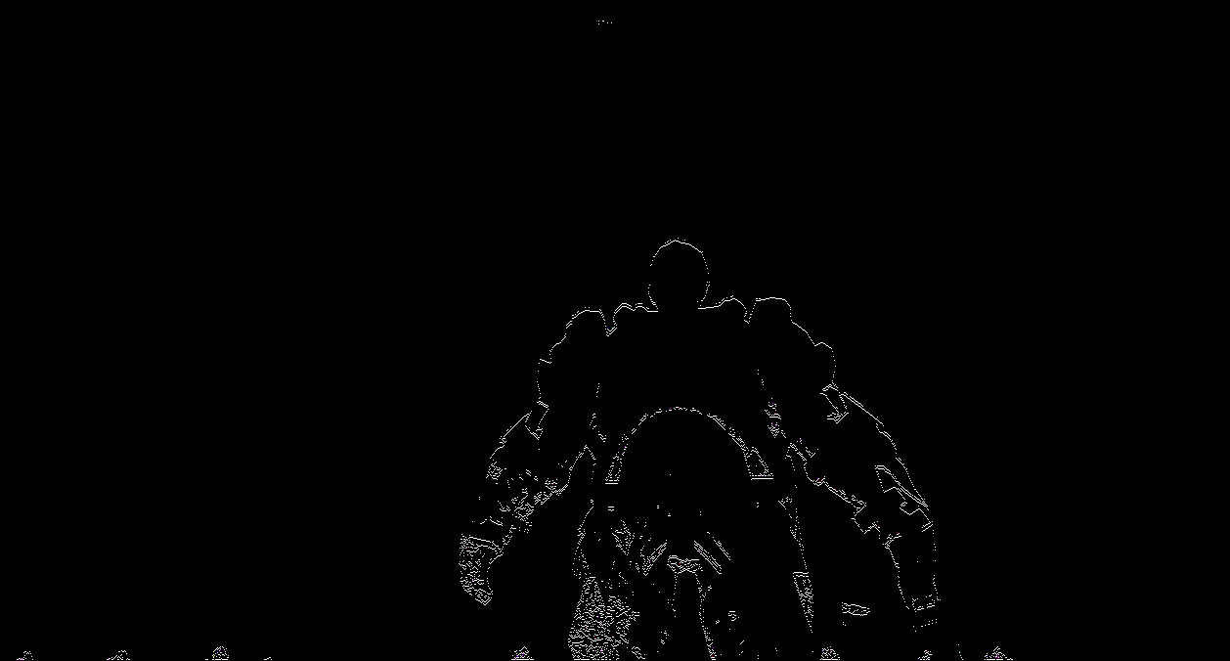

Pictured: The use of Sobel edge detection, highlighting the visible change in colour across the scene.